(Problem #2) Face Mask Detection: Given an image with a face of a person, you are expected to build a model that classifies whether that person is wearing a mask or not.

Link for data set : <https://drive.google.com/drive/folders/1P3gIgFUMbdl5tSqx1pK385bz4t0mxEvW?usp=share_link>

The data contain two classes mask and no mask , the training image data = 4489

First the python version I used is 3.10 and in this task I used both of Jupyter and PyCharm, let’s start:

First, I created a python folder to train the data set with CNN architecture in jupyter (you can also used google colab) :

1. Import required libraries.

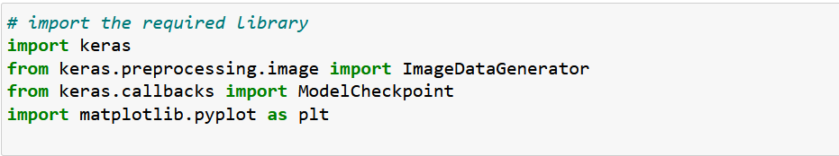

1. Create a train , valid, and test path (you have to change the path when you run it in your device note [ \ 🡪/]

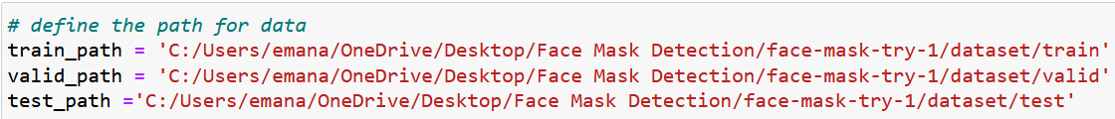

1. Now we have to perform Data Augmentation on the training and validation data

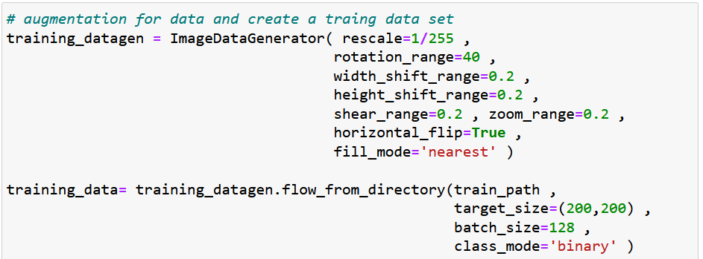

1. Create a function to visualize the image

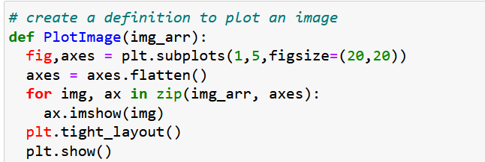

1. Define the checkpoint to track the training result

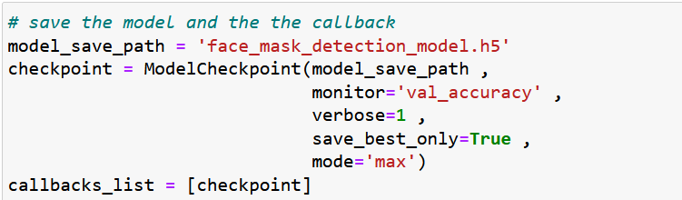

1. Now we want to create our own CNN architecture (also you can use pre-trained model ) using keras API

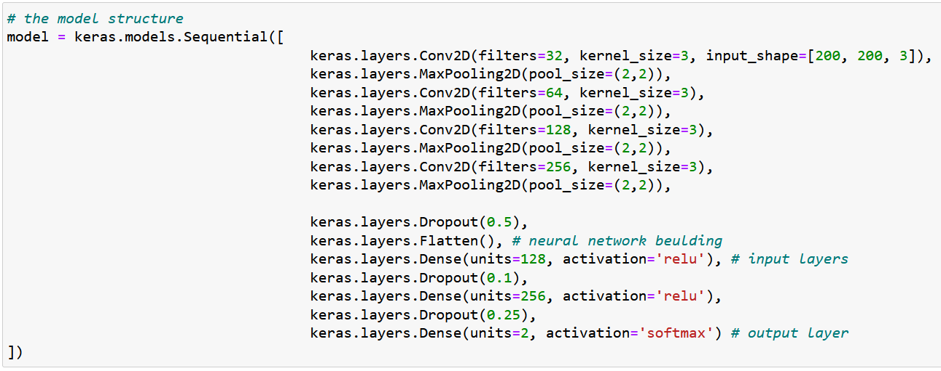

1. Compile the model

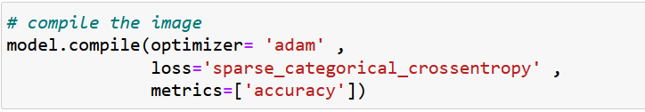

1. Let see the detail of model by using the summary function

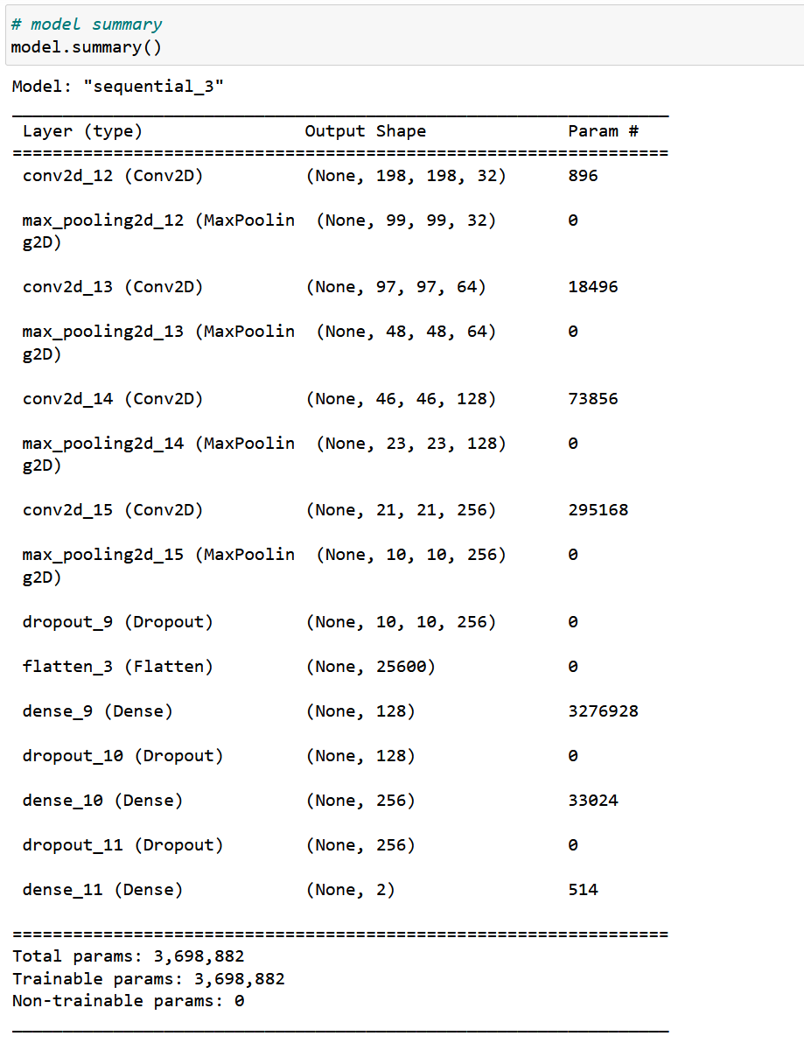

1. Fit the model

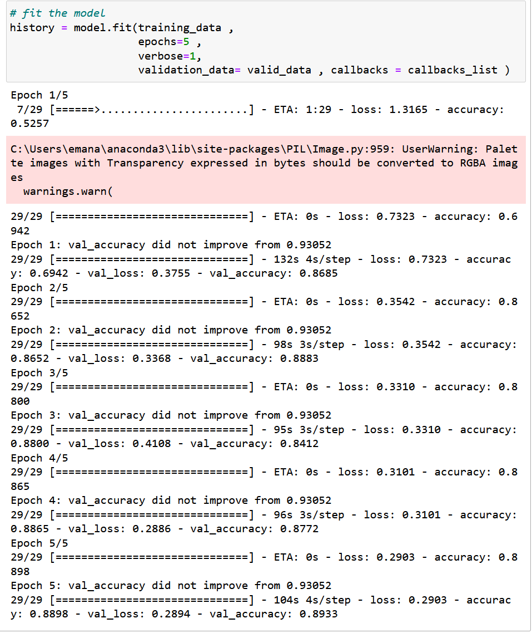

As we can see we use 5 epochs and the accuracy for training was 0.8898

And for val_accuracy 0.8933

1. Now we want to save the model to use it with other python folder we will built it next

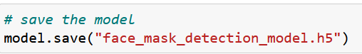

1. Augment the test data set

1. Evaluate the test data

The result of this evaluate in accuracy metrics

Know after we have trained model know we build the python folder contain method for classify image

1. Import required libraries.

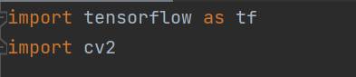

1. Load the model that we have from training model ( face_mask_detection_model.h5)



You have to change the path if you run it and change (\) to (/)

1. Load the image path

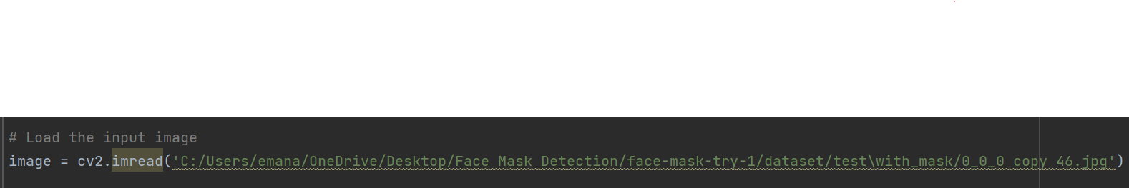

1. Now we have to prepare the image if you want more detail go to task 1 face blurring

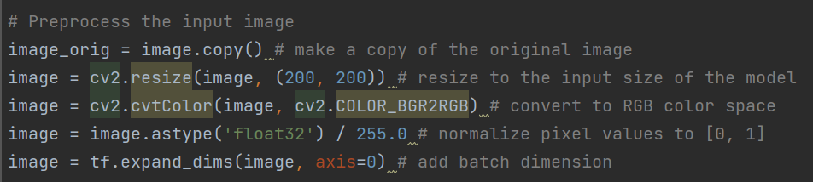

1. Know we call the model to predict the image that we upload

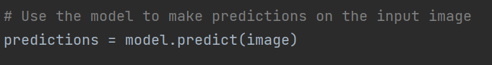

1. Get the predicted class label

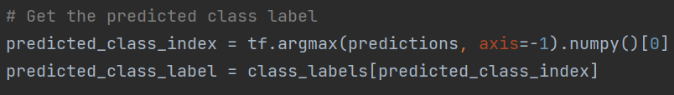

1. Display the input image and predicted class label

The result below :

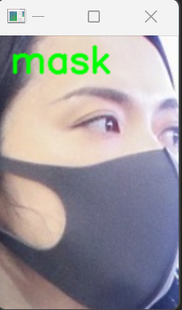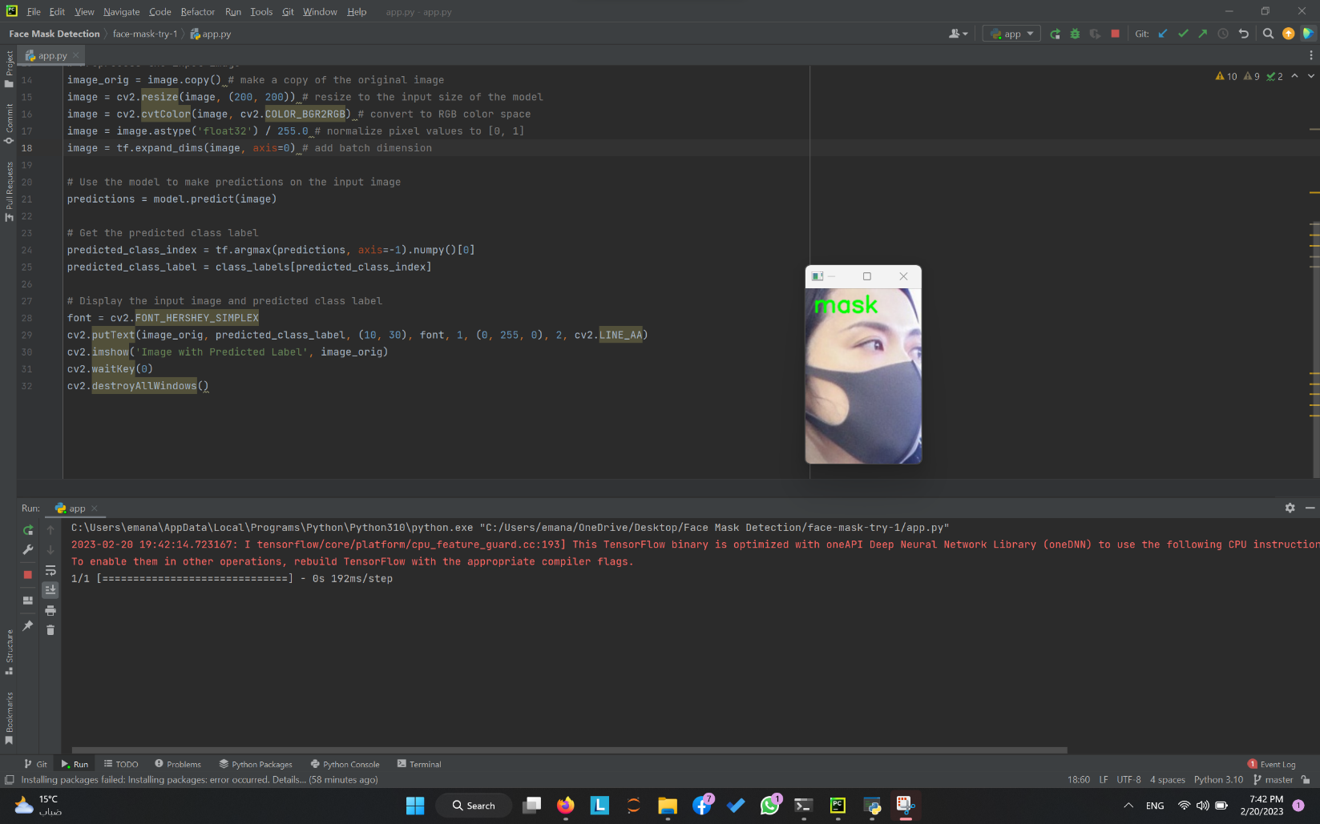

Now for addition a create another python file for webcam as follow:

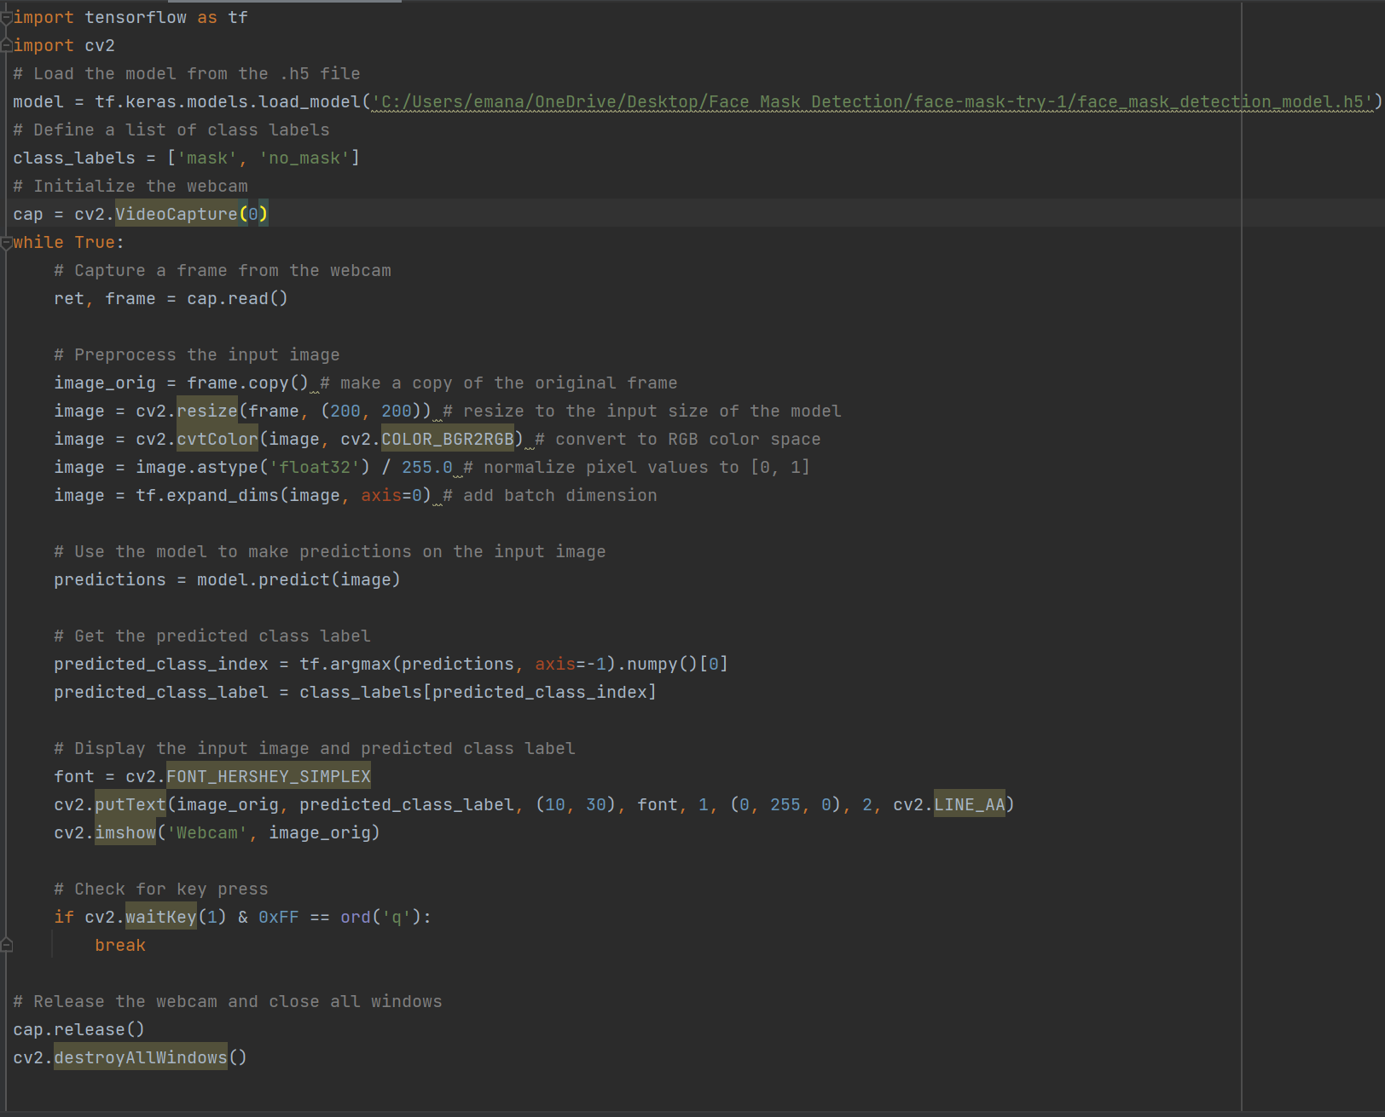

You can see the result of webcam in “result-face-mask-detection-video”

Now if we want to get higher accuracy we can edit the follow things:

1. Epochs size : increase the epoch size will made the model more accurate
2. Pre-trained model: you can use a pre-trained model and definitely you will get more accurate model
3. Hyperparameter: you can tune the parameter like learning rate
4. Data: get more data

Eman wasfi Azaizeh

Emanaz2001@gmail.com